**First Increment Report**

Project Title: **Assistance to Farmers by Effective Data Analysis**

Team**#** **10**

Team Members

**Maniraj Mohareer Sunil Kumar Madikanti Arvind Tota Hari Naga Raju Velivela**

**Project Goal and Objectives**

The core idea of this project is to provide assistance to farmers in boosting yield of their agriculture crop, supporting & guiding them throughout the process, from choosing a crop; till they sell the yield completely. The way we do is suggesting them with other probable crops that can be grown in their particular farm which are determined by various factors like; real time weather, chemical composition of the soil in which crops are grown, cycle of crops that were being grown over the years in that land. We also provide short term crops that can be grown when the major crop is germinating. We suggest methods to reduce the excessive use of fertilizers and pesticides, thereby promoting natural methods & effective utilization of the space in the field without increasing the competency to the major crop.

* **Motivation**

Data Analysis has become very popular, analysis of data refers in examining data and deriving fruitful conclusion out of that data. Conventional methods are given a lot of preference in agriculture, modifying our pace of cultivation could increase the output considerably. Applying ingenuous data analysis to the vast amount of data gathered, will let us narrow down to a list of most efficient growing crops, other than the regular ones. This whole guidance could benefit the farmer in many ways. Along with the assistance given to the operations done on the field, helping them in selling the yield with digital marketing could improve the lives of farmers in many ways.

* **Uniqueness**

Use of predictive analysis, a data mining technique; and determining the possible sustainable crops for a particular agricultural area by observing the patterns of the existing data makes this approach unique. Helping the farmers, dealing with the buying and selling of inputs and output yield also makes this not-like-one before.

* **Objectives**

1. **Suggesting alternate crops to increase productivity of the land.**

Lots of gathered data will be ready for analysis before the implementation of the project. Analysis will be done by inspecting, cleaning, transforming and modelling data with a goal of discovering useful information. This useful information combined with the user’s input data, we or the program, gives out a list of probable crops that can be chosen alternatively than the conventional crop.

This gathered data includes, real time weather monitoring system even.

1. **Helping out through the process until the crop yields.**

On the user’s profile in the website, he/she can have access to a lot of information that is sorted in detail. They include:

1. Steps to deal with different kinds of problems that a farmer might encounter over the period of crop.
2. Tips to improve farming yield.
3. Latest and advanced equipment that might improve their farming experience.
4. Real-time weather monitoring system.

We even, send alerts and cautions to be careful at different situations that might come along the way.

1. **Supporting in selling the yield with digital marketing.**

We will bridge the gap between the farmer and the retailer as a digital marketing website and manage the logistics and make it easy for the farmer to sell the yield at the comfort of sitting at home.

* **System Features**

1. **Website**

The website contains the gathered data tables from different sources, which include Geographical Conditions of the soil, Real-time weather monitoring: all these function in the back end. With good user interface, access will be easy and also each farmer can hold an account on the website. The very first time he creates an account, he needs to input the details of the crops and yield that had been grown on the farm over the years.

1. **Dashboard**

The account holders of the website will have a dashboard, on which the real-time factors can be easily seen, which makes it very easy to deal with the changes in the weather, monitor his resources. And even, a caution or alert will be sent to the farmer’s email id whenever there is a need.

* **Existing Services/ REST APIs**

i) Widgets

* Buttons, Text Fields, Images, Carousel, Navigation header, Sidebar, Divisions, Containers.

ii)API

* Google Cloud Prediction API
* Clarify API
* Authentication using Google Account
* Authentication using Facebook Account
* **Detail Design of Features (using tools)**

1. Activity diagram

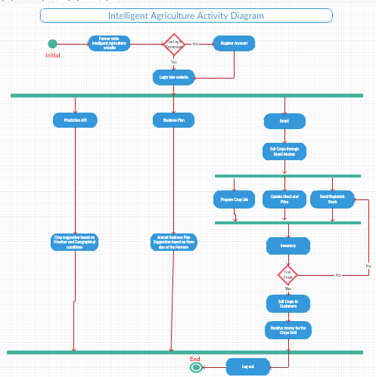

1. Sequence diagram

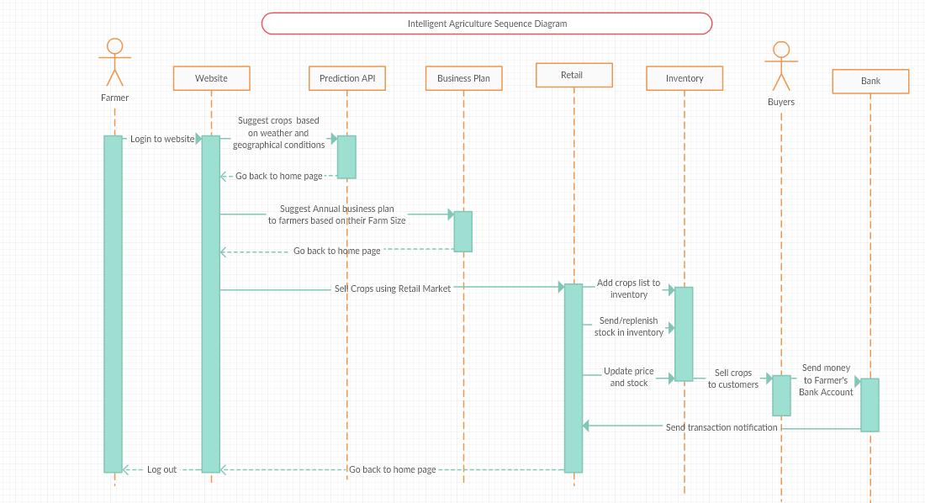

1. Wireframe

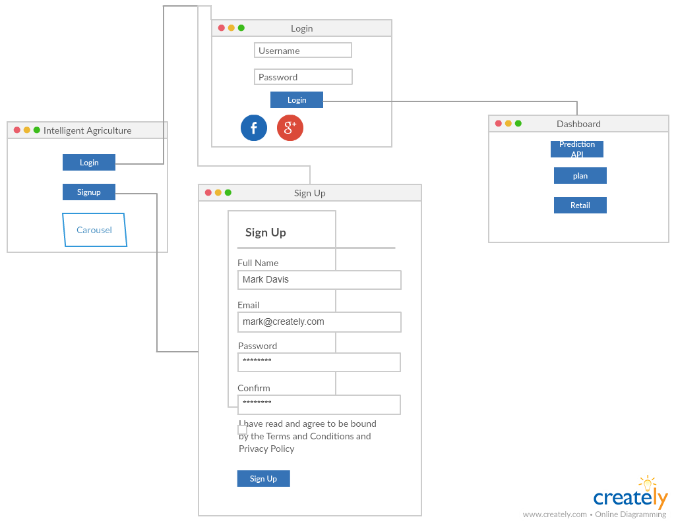

* **Testing and Deployment**

**1.Welcome Screen with Carousel**

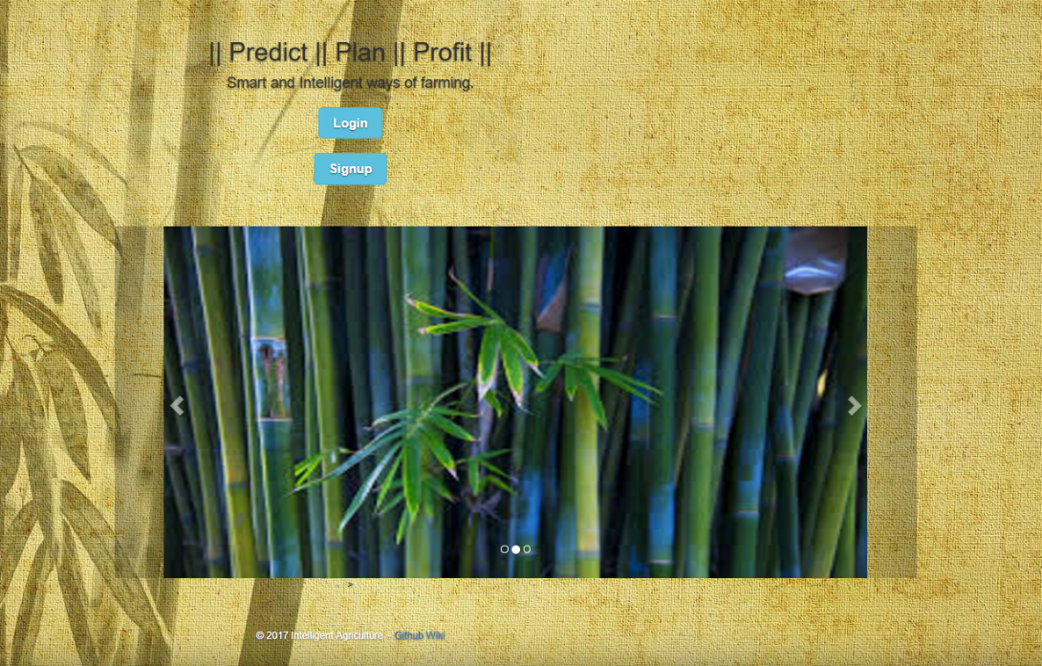

**2.Image Sliding**

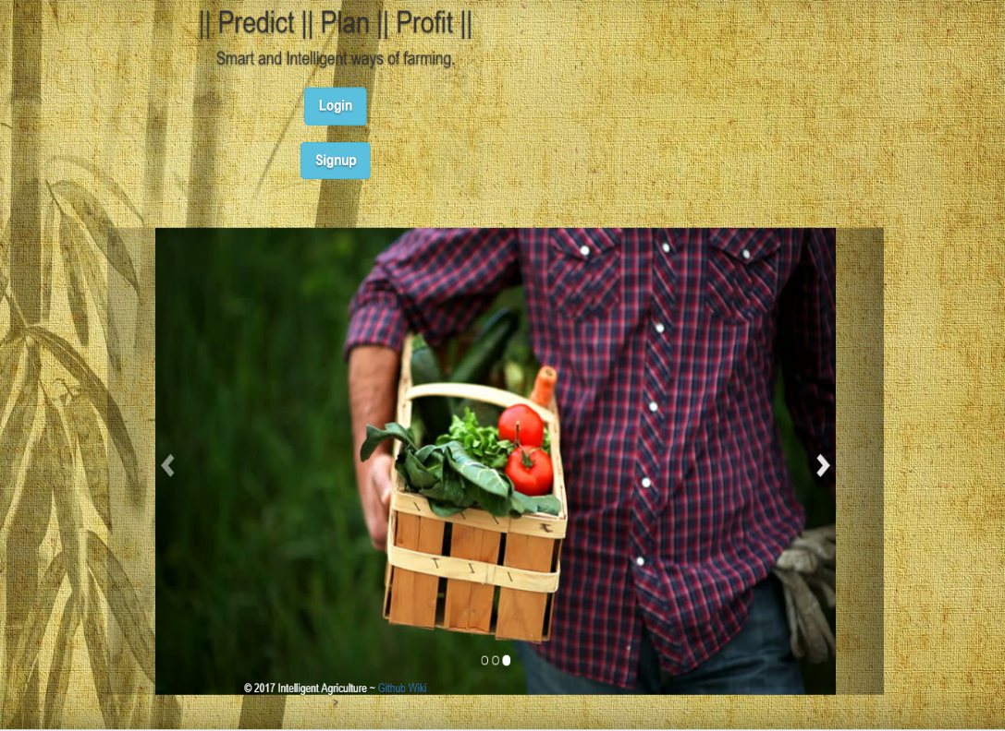

**3.Login**

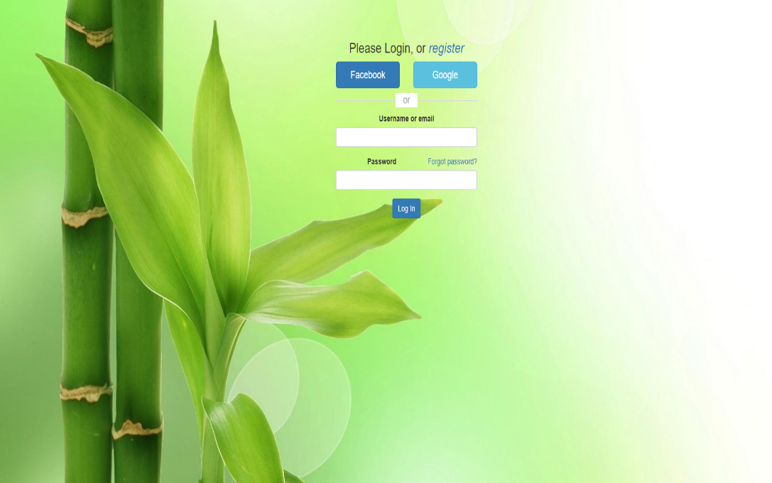

**4.Signup**

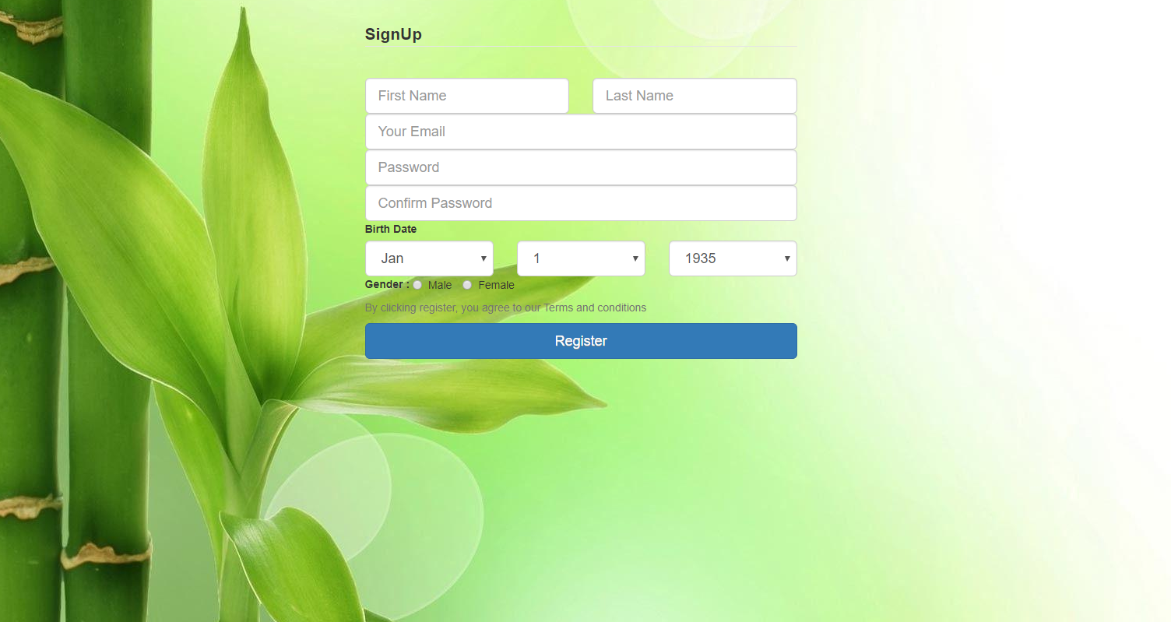

**5.Testing by logging in using Local Storage**

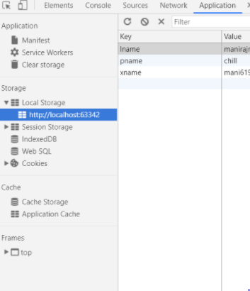

**Burndown Activity Chart**

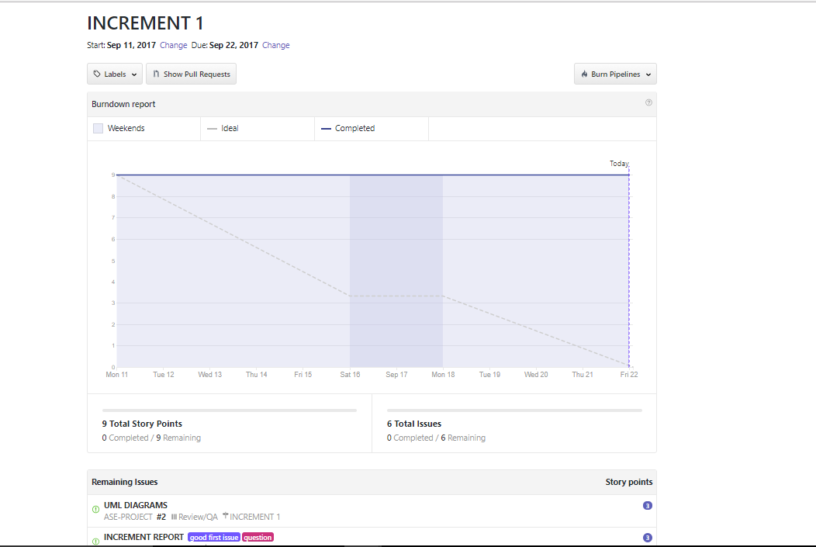

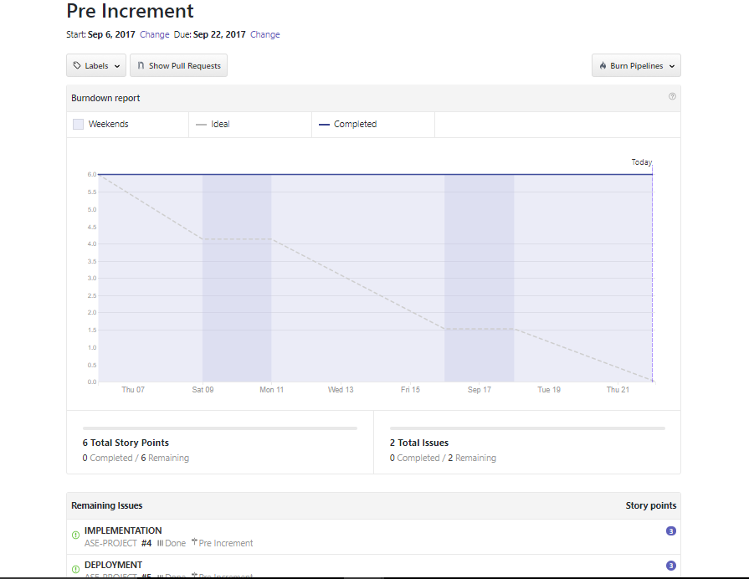

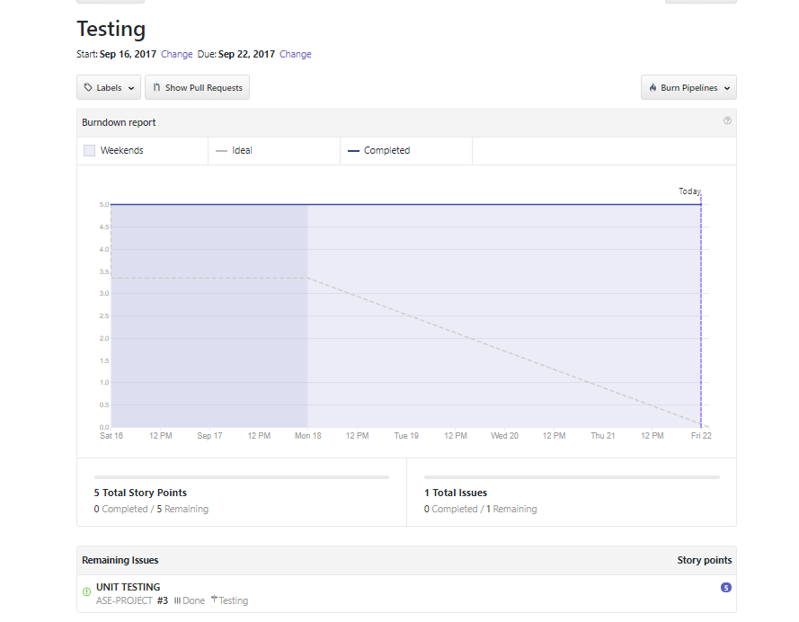

**Project Management**

**Work Completed**

1. Project Overview Design Flow
2. UI building
3. Wireframes, Sequence and Activity Diagram, Zen Hub and Documentation

**Work to be completed**

1. Database design
2. Class Diagram and State Diagram.
3. Data Collection
4. Investigation on Google Cloud Prediction API and Clarify API